**Conch Fritters**

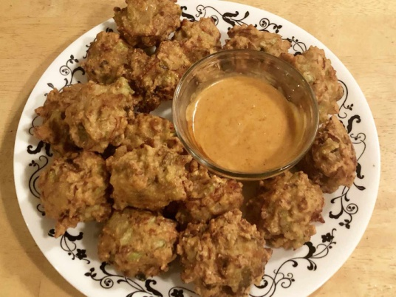

**INGREDIENTS**

**Fritters:**

1 quart oil for frying

¾ cup all-purpose flour

½ cup milk

1 egg

ground cayenne pepper to taste

seasoned salt to taste

salt and pepper to taste

1 cup chopped conch meat

2 stalks celery, chopped

½ onion, chopped

½ green bell pepper, chopped

2 cloves garlic, chopped

**Dipping Sauce:**

2 tablespoons ketchup

2 tablespoons lime juice

1 tablespoon mayonnaise

1 tablespoon hot sauce

salt and pepper to taste

**METHOD**

1. Heat oil in a deep fryer or large saucepan to 375 degrees F (190 degrees C).
2. Make the fritters: Mix flour, milk, and egg in a large bowl until smooth. Season with cayenne pepper, seasoned salt, salt, and pepper. Mix in conch meat, celery, onion, bell pepper, and garlic.
3. Drop the batter by rounded tablespoons into hot oil in batches; fry until golden brown on all sides, about 5 minutes. Drain on paper towels.
4. Make the dipping sauce: Mix ketchup, lime juice, mayonnaise, hot sauce, salt, and pepper together in a small bowl. Serve dipping sauce on the side with fritters.

Tips

Conch can be replaced with any seafood. We followed the same recipe but replaced conch with chopped calamari. It turned out awesome! We cannot wait to try it with shrimp or crab meat.